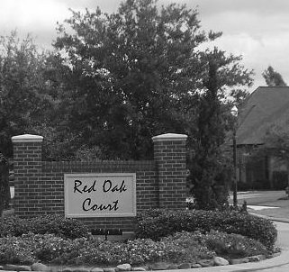
Minutes
of the Annual Membership Meeting
Red Oak Court Community Association
On January 13, 2014

The 2014 annual meeting of the membership of Red Oak Court Community Association, Inc. was called to order by Board President Max Royalty at 7:05pm. The meeting was held at 24 Red Oak Ct.

Max welcomed those in attendance and introduced those members who have moved into the neighborhood in the past year.

The minutes from the last annual meeting were approved by voice vote with no changes or additions. Lucy Weeks, treasurer, provided a financial report for the period ending December 31. She stated that the loan from Benchmark Builders has been completely repaid. She also noted that we face expenses in the next year for replacement/repair to lighting, sprinkler system and fence. There were no questions concerning the financial report. The current cash balance as of 1/13/2014 is $3,961.78 with assessments receivable adding to that daily. With the payoff of the Benchmark loan, the Association has no liability balance. A motion was made, seconded, and passed by voice vote to accept the financial report.

On behalf of the membership, Max thanked Nancy Williams for again providing the Christmas decorations for the entrance to our neighborhood.

Andy Smith explained the maintenance completed this year and the details of upcoming costs for sprinkler system and landscape lighting. A suggestion was made that we investigate other options for lighting to save money. Van Kent noted that he is willing to help with maintenance tasks if he is made aware of the need. This could save the Association considerably on labor costs for routine repairs. Several others agreed that they would be willing to help, also. A discussion also ensued concerning removal of dirt from the lower part of the fences to prevent premature rot. Gary Weeks explained a system he uses to accomplish that. Because of this problem, the perimeter fence behind #25 is in need of replacement now.

Lucy stated that we are entering a new contract with Rodrigo Ramirez for landscape maintenance that will include mulching and planting annuals, two items that were separately paid in the past. Donna Boyd stated that the flowers at the entrance have been a disappointment and hopes that something can be done to improve that. A discussion of possible solutions occurred, with the option of adding a border and raising the bed considered. Lucy also asked that any requests for board action be put in writing to one or more board members. This can be done by email if desired.

The ballots for electing new board members and approval of covenant amendments were distributed. In discussing the change to Article IX, Sections 20 and 21, the need for modification arose. A motion was made by Jeanne Halliday to remove Section 21 rather than change it. The motion passed by voice vote. Following this, a motion made by John Hoss to change the minimum lease period from 60 days to one year also passed by voice vote. It is understood that waivers to that minimum can be granted by the Board in special circumstances. Voting then occurred by written ballot with the result that Judy Foster and Jeanne Halliday were elected to the Board and both covenant amendments, as modified, were approved by 75% of the membership. These amendments will be available on the association web site for viewing and downloading.

There being no further business, the meeting was adjourned by Max at 8:25pm.

Submitted: ___________________________________________
Andy Smith, Secretary

Approved: ___________________________________________
Max Royalty, President

